A Guide to British Birds

Credit to the author Amalasuntha

http://chesterfieldpagans.org/2011/01/05/a-pagans-guide-to-british-birds/
5 January 2011 by Amalasuntha
Now that we’re out of the snows of Winter, there are plenty of birds singing their little hearts out. If you’re anything like me, I can tell that it’s birds making the noise, but that’s about it. So, here’s a quick guide to some of the sights and sounds of common British Birds:
(the sound clips are MP3′s and are taken from the BBC, just click the link to play)
Chaffinch
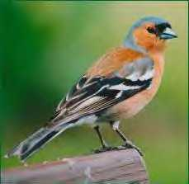
Chaffinch
The Chaffinch is our commonest finch in the British Isles, the male finch is pictured above, the female is brown in colour. Hearing a Chaffinch is one of the first signs of Spring returning Birdsong – Chaffinch.

Robin
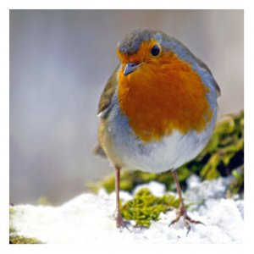
Robin
Distinctive red breasted males (as above) and the brown females both sing. Birdsong – Robin
House Sparrow
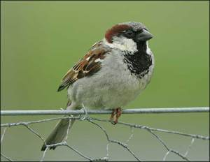
house sparrow
Often heard in hedgerows and descending en-masse on bird feeders and tables. The male is as above, the female is brown. Numbers are now in decline, as habitats grow rarer.
RSPB House Sparrow page(with audio clip)

Blue Tit
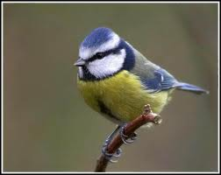
blue tit
The top species for eating aphids, the bane of many gardeners. Will return to the same nesting box year after year. Was noted in the 1960′s as the bird which taught other individuals of it’s kind to attack the foil tops of milk bottles to get at the cream. This has declined with the lessening of doorstep deliveries, and milk being provided in cartons from supermarkets. Birdsong – Blue Tit
Blackbird
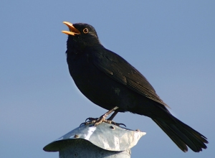
blackbird
Will eat insects, earthworms, berries and fruits, The male is black,(as above) and the female brown. Birdsong – Blackbird

Song Thrush
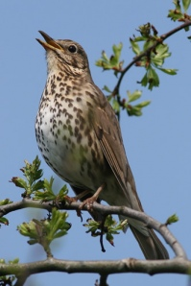
Song Thrush
Will mostly eat insects, but also worms, snails and fruit. May leave snail shell remains around an ‘anvil stone’ which it uses to crack the shells. Birdsong – Song Thrush
Magpie
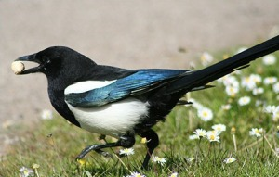
magpie
Black, white, long tail. Persistent, irritating and liable to go for shiny things. Nuff said. One of the few species able to recognise itself in a mirror test. Call sounds like the Chak-chak-chak of a machine gun. It’s distinctive, but I can’t seem to find a recording of it available online. RSPB Magpie page (with audio clip)

Wood Pigeon
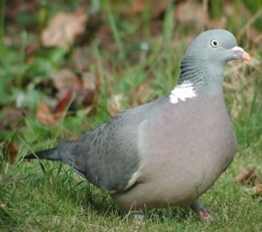
Common Wood Pigeon
The UK’s major agricultural bird pest and one of the most popular species for shooting. Forms very large flocks and takes off with a large clattering sound. Birdsong – Wood Pigeon
Great Tit
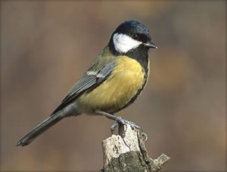
Great Tit
Will feed on insects and spiders, but may go after Pipistrelle bats in winter when food is scarce. Like the Blue Tit, this species has been recorded attacking foil milk bottle tops to get at the cream. Birdsong – Great Tit
Further online resources:
The National Trust Guide to Birdsong
RSPB – Garden Wildlife
BBC – British Birds

